Stakeholder Analysis Report: OptimAlze Buddy

Executive Summary
OptimAlze Buddy is an AI-powered digital services agent designed to transform citizen-government interactions through conversational interfaces, automated workflows, and real-time document validation. This analysis examines the complex ecosystem of stakeholders involved in public sector digital transformation, balancing citizen needs with government operational requirements. The system's success depends on managing relationships across political, administrative, technical, and citizen domains, with particular attention to data security, regulatory compliance, and public trust. This report provides a framework for strategic stakeholder engagement to ensure successful implementation and adoption.
1.0 Introduction and Methodology
Digital transformation in the public sector presents unique challenges involving legacy systems, bureaucratic processes, and diverse citizen populations. OptimAlze Buddy aims to simplify these interactions through AI-driven automation. This analysis employs:
- Multi-dimensional Identification: Cataloging stakeholders across political, administrative, technical, and citizen categories
- Power-Interest Mapping: Analyzing influence dynamics in government procurement and service delivery
- Impact-Assessment: Evaluating how the solution affects different stakeholder groups
- Risk-Trust Analysis: Special focus on public trust and data security concerns
Primary analytical tools include the Influence-Authority Matrix and Adoption-Impact Matrix, adapted for public sector contexts.
2.0 Stakeholder Identification and Categorization
Table 1: Government & Administrative Stakeholders
Stakeholder Group | Primary Interests & Concerns
Political Leadership (Mayors, Council Members) | Public perception, re-election impact, cost savings, service improvement metrics, quick wins
Department Heads & Senior Administrators | Operational efficiency, budget control, staff management, risk mitigation, compliance
Frontline Government Staff | Job security concerns, workload changes, training needs, system usability, trust in automation
IT & Digital Transformation Teams | System integration, data security, scalability, compliance with government IT standards, maintenance burden
Legal & Compliance Officers | Regulatory compliance, data protection (GDPR, etc.), liability, audit trails, accessibility requirements
Table 2: Citizen & External Stakeholders
Stakeholder Group | Primary Interests & Concerns
Primary Users: General Citizens | Service accessibility, ease of use, time savings, trust in accuracy, privacy protection
Vulnerable User Groups (Elderly, Disabled, Non-tech-savvy) | Digital inclusion, alternative access methods, simplicity, human fallback options
Business Users (Small Businesses, Contractors) | Efficiency, reliability for compliance submissions, integration with business processes
Advocacy Groups & Community Organizations | Equity of access, transparency, accountability, data privacy protection
Media & Watchdog Organizations | System performance, cost-effectiveness, privacy implications, failure incidents
Technology Vendors & System Integrators | Partnership opportunities, integration projects, maintenance contracts, data sharing
Academic & Research Institutions | Case study opportunities, public service innovation research, impact assessment
Unions & Employee Associations | Job impact, retraining requirements, workload redistribution, employee rights
3.0 Stakeholder Analysis Matrices
Matrix 1: Influence vs. Authority Analysis
This matrix is particularly relevant for government contexts where formal authority structures dictate decision-making.
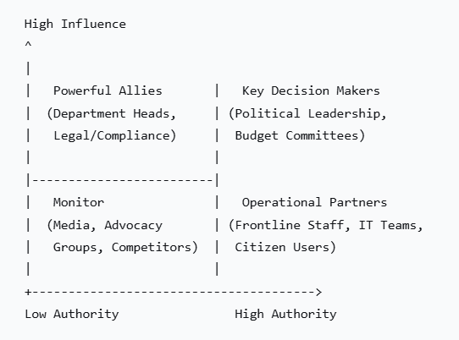
*Figure 1: Influence-Authority Matrix for OptimAlze Buddy Stakeholders*
High Influence, High Authority (Key Decision Makers)
- Political Leadership: Mayors, council members who control budgets and strategic direction
- Budget Committees: Control funding allocation and project approval
- Senior Government Executives: Have authority to mandate adoption across departments
High Influence, Low Authority (Powerful Allies)
- Department Heads: Can champion or block implementation within their domains
- Legal & Compliance Officers: Can halt projects over regulatory concerns despite lacking budget authority
- Media Outlets: Shape public opinion and political pressure without formal authority
Low Influence, High Authority (Operational Partners)
- IT Departments: Implement and maintain the system but often lack strategic influence
- Frontline Staff: Directly affected and can sabotage or support adoption through daily use
- Citizen Users: Ultimately determine success through adoption rates but lack formal authority
Low Influence, Low Authority (Monitor)
- Advocacy Groups: Can raise concerns but limited direct power
- Competitors: Market alternatives but government procurement is complex
- Academic Institutions: Provide insights but not decision-makers
Matrix 2: Adoption Impact vs. Trust Requirements
Public sector deployments require special attention to trust and perception.
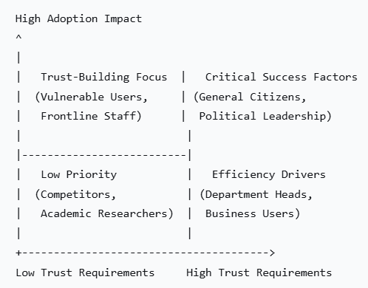
*Figure 2: Adoption Impact-Trust Matrix for OptimAlze Buddy Stakeholders*
High Impact, High Trust Requirements (Critical Success Factors)
- General Citizens: Widespread adoption requires high trust in accuracy and privacy
- Political Leadership: Must trust the system to deliver promised benefits without political risk
High Impact, Low Trust Requirements (Trust-Building Focus)
- Vulnerable User Groups: May resist adoption due to technology anxiety; require special trust-building
- Frontline Staff: May distrust AI replacing their roles; need reassurance and inclusion
Low Impact, High Trust Requirements (Efficiency Drivers)
- Department Heads: Require trust in ROI and operational improvements
- Business Users: Need trust in reliability for compliance purposes
Low Impact, Low Trust Requirements (Low Priority)
- Competitors: Naturally distrustful but limited impact
- Academic Researchers: Interested but not critical for adoption
4.0 Detailed Engagement Strategies & Communication Plan
Table 3: Engagement Strategy for High-Priority Stakeholders
Stakeholder Group | Key Messages | Communication Channels | Engagement Frequency
Political Leadership | "Transform citizen satisfaction scores"  "Achieve digital government milestones"  "Demonstrate innovative leadership"  "Reduce operational costs while improving service" | Briefings, progress dashboards, public announcements, political committee presentations | Monthly executive updates; quarterly public reporting
Department Heads & Administrators | "Reduce administrative backlog by X%"  "Improve first-contact resolution rates"  "Streamline document processing workflows"  "Free up staff for complex cases" | Operational meetings, performance metrics, case studies, ROI analysis | Bi-weekly operational reviews; monthly performance reporting
Citizen Users | "Get government services faster and easier"  "24/7 access to information and services"  "Reduce errors in your applications"  "Your privacy and data are protected" | Public website, social media, community workshops, service points, traditional media | Continuous public communication; quarterly satisfaction surveys
Frontline Staff | "Your expertise is still essential"  "Reduce repetitive administrative tasks"  "Focus on complex cases that need human judgment"  "Help us train and improve the system" | Staff workshops, training sessions, user feedback channels, pilot programs | Weekly during implementation; monthly user group meetings post-deployment
Legal & Compliance Teams | "Built-in compliance with data protection regulations"  "Complete audit trails for all interactions"  "Accessibility standards integration"  "Regular security testing and updates" | Compliance review meetings, security audits, documentation reviews, legal briefings | Pre-implementation review; quarterly compliance check-ins
5.0 Risk Assessment and Mitigation
Table 4: Key Stakeholder-Related Risks and Mitigations
Risk | Description | Affected Stakeholders | Mitigation Strategy
Public Trust Erosion | Privacy concerns or system errors leading to public backlash | Citizens, Political Leadership, Media | Trust Strategy: Transparent data policies, independent security audits, clear accountability lines, human escalation options
Staff Resistance | Frontline employees fearing job displacement or refusing to use system | Frontline Staff, Unions, Department Heads | Change Management: Co-design approach, clear role evolution, retraining programs, demonstrate time savings for complex work
Digital Exclusion | Vulnerable groups unable or unwilling to use digital system | Vulnerable Users, Advocacy Groups, Political Leadership | Inclusion Strategy: Maintain traditional channels, community digital literacy programs, simplified interfaces, assisted digital support
Integration Failure | Inability to connect with legacy government systems | IT Teams, Department Heads, Citizens | Technical Strategy: Phased integration approach, robust API architecture, legacy system compatibility layers, parallel run periods
Political Risk | Project failure or controversy affecting political leadership | Political Leaders, Senior Administrators | Governance Strategy: Strong project governance, regular transparency reports, pilot before scaling, bipartisan support building
Compliance Violations | Failure to meet data protection or accessibility regulations | Legal Teams, Regulatory Bodies, Citizens | Compliance Strategy: Privacy-by-design, regular legal reviews, accessibility testing, compliance officer involvement from start
Table 5: Success Metrics by Stakeholder Group
Stakeholder Group | Key Success Metrics | Measurement Approach
Political Leadership | Citizen satisfaction scores, Media sentiment, Re-election impact, Cost savings | Public opinion polls, Media analysis, Budget analysis, Election results
Department Heads | Processing time reduction, Staff productivity, Error rates, Cost per transaction | Operational metrics, Staff surveys, Quality audits, Financial analysis
Citizen Users | Task completion time, Success rate, Satisfaction scores, Net Promoter Score | User analytics, Post-service surveys, Abandonment rates, Public feedback
Frontline Staff | Workload distribution, Job satisfaction, Training completion, System adoption rate | Staff surveys, Usage metrics, Performance reviews, Training records
IT Teams | System uptime, Integration success, Security incidents, Maintenance effort | System monitoring, Project reviews, Security audits, Resource tracking
Legal/Compliance | Regulatory audit results, Data breach incidents, Accessibility compliance | Audit reports, Incident logs, Compliance testing, Legal review outcomes
6.0 Implementation Phasing and Stakeholder Timeline
Table 6: Stakeholder Engagement Timeline
Phase | Duration | Key Stakeholder Activities | Success Indicators
Phase 1: Planning & Design | Months 1-3 | • Political approval secured  • Department needs assessment  • Citizen focus groups  • Legal compliance review | Budget approval, Requirements document signed, Compliance checklist completed
Phase 2: Pilot Development | Months 4-6 | • IT infrastructure setup  • Staff training development  • Pilot service selection  • Media communication plan | Pilot environment ready, Training materials approved, Pilot services identified
Phase 3: Limited Pilot | Months 7-9 | • Controlled citizen testing  • Staff feedback collection  • Performance monitoring  • Adjustment implementation | Positive user feedback, System stability achieved, Process improvements identified
Phase 4: Gradual Rollout | Months 10-15 | • Additional services added  • Expanded user training  • Continuous improvement  • Public awareness campaign | Adoption rates increase, Error rates decrease, Public awareness grows
Phase 5: Full Operation | Months 16+ | • System optimization  • New feature development  • Regular reporting  • Ongoing stakeholder engagement | Target adoption achieved, Cost savings realized, Continuous improvement cycle
7.0 Conclusion and Recommended Actions
OptimAlze Buddy represents a significant transformation in public service delivery, requiring careful navigation of complex stakeholder relationships. Key insights include:
- Dual Accountability: Must satisfy both political leadership (quick wins, public perception) and administrative leadership (operational efficiency, risk management)
- Trust as Foundation: Public trust is non-negotiable and must be built through transparency, security, and reliability
- Inclusive Design: Must serve diverse citizen populations with varying digital literacy and accessibility needs
- Staff Partnership: Frontline employees are critical to success and must be partners, not targets, in the transformation
Critical Success Factors:
- Political Champions: Secure strong support from visible political leaders
- Staff Inclusion: Involve frontline staff in design and implementation
- Phased Approach: Start small, demonstrate success, then expand
- Transparent Governance: Clear accountability and regular public reporting
- Continuous Feedback: Mechanisms for ongoing citizen and staff input
Immediate Next Steps:
- Establish a multi-stakeholder steering committee with political, administrative, staff, and citizen representation
- Conduct privacy impact assessment and security review before any development
- Develop a comprehensive change management program addressing all staff levels
- Create a public communication strategy explaining benefits, privacy protections, and alternative access options
- Identify quick-win services for initial pilot to demonstrate value rapidly
By systematically addressing the needs and concerns of this diverse stakeholder ecosystem, OptimAlze Buddy can successfully transform citizen-government interactions while building public trust and achieving operational excellence.

For: OptimAlze Buddy Implementation Steering Committee
Confidentiality: Internal Government Use - Sensitive

